ADIYAMAN UNIVERSITY
2018-2019 ACADEMIC YEAR MEVLANA EXCHANGE PROGRAMME
ACADEMIC STAFF APPLICATION FORM

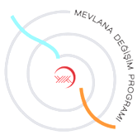
PERSONAL INFORMATION
Name- Surname
ID Number
Faculty/School
Department/Programme
Academic Title
Gender
E – mail
Tel (Office)
Tel (GSM)

APPLICATION INFORMATION
Name of the Hosting Higher Education Institution: | Adıyaman University
Host City / Country: | Adıyaman, Turkey
MEVLANA Institution Code of the Hosting Higher Education Institution: | D02-MEVLANA-01
Name of the Faculty/ Department to which you are applying:
Teaching Subject Area:
Degree: | Associate Degree DegreeMaster DegreeDoctorate Other

