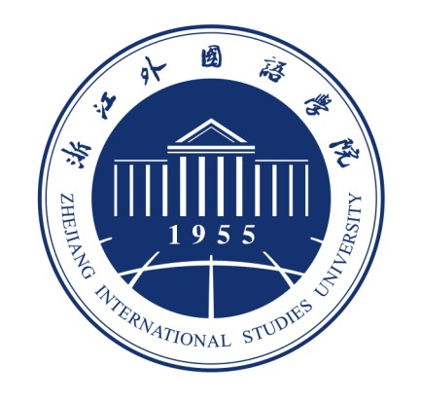
Zhejiang International Studies University
浙江外国语学院外籍学生入学申请表
Application Form for International Students
No:
英文姓名Family Name: | First Name: |  |  |  |  |  | Middle Name: |  |  |  | 照片  Photo
中文姓名Chinese Name: | 性别Gender |  |  |  | 婚姻状况Marital Status: |  |  |  |  |  | 照片  Photo
出生日期Date of Birth:  年(Y) 月(M) 日(D) |  |  |  |  | 出生地Country of Birth: |  |  |  |  |  | 照片  Photo
国籍Nationality: |  |  | 护照号码 Passport No: |  |  |  |  | 护照有效期 Passport Valid Until:  年(Y) 月(M) 日(D)
电子邮件E-mail Address: |  |  |  |  | 宗教 Religion:
本国地址Permanent Home Address and Telephone No.
街道Street__________________________________________________________________________________
城市City______________________国家Country__________________邮编 Zip code___________________
电话 Phone Number________________
邮寄地址（若与上述地址不同） Mailing Address (if different)：
街道Street_________________________________________________________________________________
城市City______________________国家Country_______________邮编 Zip code______________________
电话 Phone Number___________________
学习经历 Education Background:
学校名称Name of School/College/University |  | 专业  Major |  | 开始年月  (mo/yr) |  |  |  |  | 结束年月  (mo/yr) | 所获学位/年份 Degree Earned/Year
汉语熟悉程度 The Chinese Language Proficiency:
口很好Excellent 口好Good 口一般Fair 口入门Beginning
你曾经学过多长时间汉语 (How long have you learned Chinese)?
口600学时以上/Over 600 Class hours 口400-600学时以上/400-600 Class hours
口200-400学时/200-400Class hours 口50-200学时/50-200 Class hours
口50学时以下/ Less than 50 Class hours
汉语水平考试等级 (The Chinese proficiency test/HSK):
口考过，____级/Yes, band____. 口考过，没有级/Yes, but no grades 口没有考过/No
申请类别 Applying as:
□学历生Degree Student:
□本科生Undergraduate Student □专科生 Diploma Student
□非学历生 Non-degree Student:
□汉语进修生Language Student □交换生Exchange Student □短期访问生Short Term Visiting Student
来浙江外国语学院学习的专业或课程
Intended major or program studied at ZISU:

申请学习期限 年 月 至 年 月
Intended duration of study: from Yr Mo to Yr Mo
推荐人或单位/电话/电子邮件  Recommended by _____________________  Phone Number: _______________________  E-mail Address: _______________________ |  |  |  |  |  | 经费来源 Source of Funding:  口自费 Self-supporting  口奖学金 Scholarship  口其他 Other
申请人保证：I hereby affirm that:
上述各项中所提供的情况是真实无误的；
All the information given in this form is true and correct;
在中国学习期间将遵守中国政府的法律和学校的规章制度；
I shall abide by the laws of the government of P.R. China and the regulations of the University
申请人签字： 日期：
Applicant’s signature: Date:
请申请人将本申请表及以下（1）（2）（3）份材料发送至study@zisu.edr.cn
Applicants should submit the following documents with the application form to Program Manager at
study@zisu.edu.cn
（1）最高学历证书 Photocopy of Highest Degree Certificate
（2) 学习成绩单 Photocopy of Official Transcripts (with English or Chinese translation)
（3) 护照复印件 Photocopy of Passport
（4) 健康报告(有的情况下) Photocopy Health Report (if available)
Contacts:
中国浙江省杭州市文三路140号浙江外国语学院国际学院,310012
College of International Education, Zhejiang International Studies University
140 Wensan Road, Hangzhou, CHINA 310012
E-Mail: study@zisu.edu.cn
Tel/Fax: +86-571-88213035

