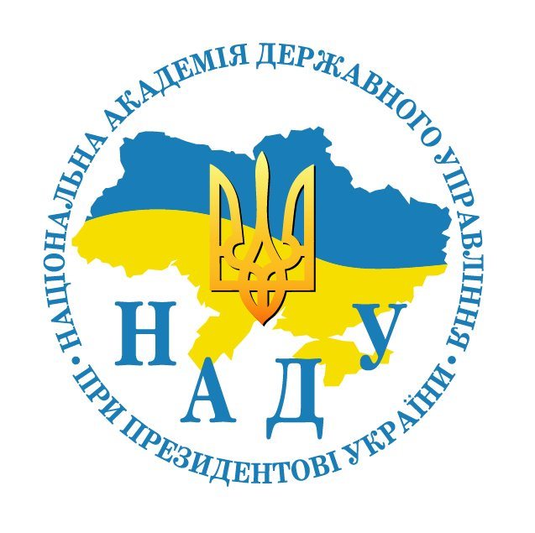 |  | 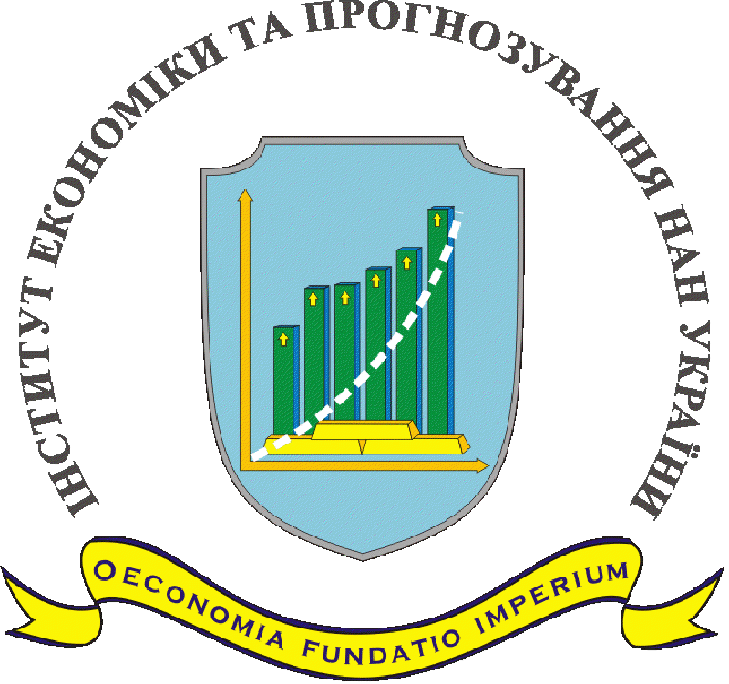 |  | 
NATIONAL ACADEMY FOR PUBLIC ADMINISTRATION
UNDER THE PRESIDENT OF UKRAINE (Ukraine)
IVANE JAVAKHISHVILI TBILISI STATE UNIVERSITY (Georgia)
INSTITUTE FOR ECONOMICS AND FORECASTING OF THE NATIONAL ACADEMY
OF SCIENCES OF UKRAINE (Ukraine)
INSTITUTE OF SOCIAL AND POLITICAL PSYCHOLOGY OF THE NATIONAL ACADEMY OF PEDAGOGICAL SCIENCES OF UKRAINE (Ukraine)
UKRAINIAN TECHNOLOGICAL ACADEMY (Ukraine)
UKRAINIAN SOCIETY OF PROMOTION FOR SOCIAL INNOVATION (Ukraine)

INFORMATION SHEET

VІІ INTERNATIONAL THEORETICAL AND METHODOLOGICAL SEMINAR
“ARCHETYPES AND PUBLIC ADMINISTRATION:
challenges and risks of social transformation”
28 May – 3 June 2016
Tbilisi (Georgia)

Contact information:
AFONIN Eduard Andriiovych (research advisor of TMS)
Mob (+38) 067 2444659
E-maіl: bpafonin@gmail.com
SUSHYI Olena Volodymyrivna (academic secretary of TMS)
Mob (+38) 067 9109926
Е-mail: a_s_y2000@yahoo.com

KYIV-TBILISI – 2016
INFORMATION SHEET
Dear colleagues!
The National Academy for Public Administration under the President of Ukraine together with the Ivane Javakhishvili Tbilisi State University, the Institute for Economics and Forecasting of the National Academy of Sciences of Ukraine, the Institute of Social and Political Psychology of the National Academy of Pedagogical Sciences of Ukraine, Ukrainian Technological Academy, Ukrainian Society of Promotion for Social Innovation invite scholars to join 7th International Theoretical and Methodological Seminar “Archetypes and Public Administration: Challenges and Risks of Social Transformation” in the framework of the initiatives by the Ukrainian School of Archetypes.
This year's contest programme framework is associated with the idea that social transformation and political modernization of the late 20th – early 21st centuries do not necessarily coincide with the model of “Western exemplar” that arose at the time of the Great Depression during 1930-1940s of the 21st century. Modern political life of the countries of the second wave of transformation leads to the appearance of new socio-economic and socio-political forms of social organization. Conflict intensity of political simulations becomes more and more pronounced, especially the one revealed by the countries of the former Soviet Union. Social and transformational process is noted by a number of new phenomena of the “converted democracy” or “democracy of the chameleons”. It seems that the current political modernization is fed by not only universals of institutional matrix and archetypes of the collective unconscious, but the specific manifestations of conscious and unconscious in different space-time implementations of socio-cultural nature of the national public entities. However, growing challenges and threats to global, regional and social integrity and security, which take effect in the context of the formation of post-modern realities of the modern world, significantly alter the traditional notions about the nature and factors of social and state development. Under these conditions, the most sensitive to the socio-transformation process is a matter of balance between the growth rate of socio-political, socio-economic and other socio-cultural forms of expression of institutional activity (freedom) of citizens and potential of the playback of psychosocial (archetypal) nature of the social reforms. This balance – between institutional form and psychological content – In fact, provides a mode of sustainable development of the society.
The purpose of the event is in unification of the interdisciplinary efforts of scholars working in different fields of social and humanitarian knowledge on solving of the archetype based methodology of theoretical and practical problems of modern public administration, related to challenges and risks arising in the context of social and transformational change.
Date: 30 May 2016.
Location: participants of 7th TMS-2016 are welcomed by the Ivane Javakhishvili Tbilisi State University – the oldest and largest higher education institution of modern Georgia, which was founded in February 1918 and today is the center of science and culture of the country. Interesting sightseeing trips, meetings and introduction to the culture and the present of Georgia will wait for the guests.
Working languages — Ukrainian, Russian and English.
Registration fee — none.
Publication fee — none.
Flight: Kyiv-Tbilisi — 28 May, Tbilisi-Kyiv – 3 June. Journey and the tours for the participants of the seminar are provided by the travel company “Olimp”, director — Vykhovanets Iryna Leonidivna (address: 04050, Kyiv, 16 Dovnar-Zapolskoho Str., phone +38 067 699 5765, +38 099 530 9490,
E-mail: olimp_tour@ukr.net).

To participate in 7th TMS-2016 one should submit:
- Application for participation — until 15 March 2016 to AFONIN Eduard Andriiovych
E-mail (bpafonin@gmail.com).
- Manuscript of the paper + photo — until 15 April 2016 both to the E-mails of AFONIN Eduard Andriiovych (bpafonin@gmail.com) and SUSHYI Olena Volodymyrivna (a_s_y2000@yahoo.com).
Requirements for the paper work see. Annex (file name: Surname_contest-2016.doc).
Quality of the portrait photo: size 3,3 х 4,6 сm, resolution 600 dpi (over 500 Кb), must be sent in a separate file (file name: Surname_contest-2016.jpeg).
In the framework of 7th TMS-2016 an international expert commission will determine the best papers of the participants, who will be awarded with monetary award:
Three incentive awards — UAH 1000 each.
It is planned to publish a Ukrainian-Russian-English special edition of an academic journal “Public Administration” that will contain the articles of the participants of 7th TMS-2016. The journal is published under scientific speciality “Public Administration”.

APPLICATION
of a participant of 7th ТМС-2016
“Archetypes and Public Administration: Challenges and Risks of Social Transformation”

Surname, Name, Patronymic Name
Ukr. ______________________________________________________________________________
Rus. ______________________________________________________________________________
Engl. _____________________________________________________________________________
Institution (name)
Ukr. ______________________________________________________________________________
Rus. ______________________________________________________________________________
Engl. _____________________________________________________________________________
Position ___________________________________________________________________________
Academic degree ___________________________________________________________________
Academic title _____________________________________________________________________
Title of the article __________________________________________________________________
Ukr. ______________________________________________________________________________
Rus. ______________________________________________________________________________
Engl. _____________________________________________________________________________
Address (to send the collected volume, including postcode and the address of the nearest post office of “Nova Poshta”): __________________________________________________________________________________
Contact information
Phone (with codes): home______________, work________________, mob._____________________
E-mail: ___________________________________________________________________________
Skype: ____________________________________________________________________________
Form of participation (mark in bold type in every line Yes / No):
1. In person – with provision of the article and willingness to present it in Tbilisi (Yes /No)
2. Off-site – with provision of the article and willingness to present it via Skype (Yes / No)
3. Do you need:
- special invitation (Yes / No)
- multimedia means for the report (Yes / No)
4. Tour to Georgia (28 May – 3 June); approximate cost of the tour +/- $600 (Yes / No)
- if yes, then note the route of the flight (Kyiv-Tbilisi /other)

REQUIREMENTS
for the structure and style of the research article

- Structure of the research article:
Surname, name and patronymic name of the author, academic degree, academic title, position, place of work, the title of the article, extended abstract (up to 800-1000 characters with spaces), keywords.
The above mentioned information is supplied in separate blocks in Ukrainian, Russian and English languages before the article. The quality of the English translation of the abstract to the article is determined by the editorial board.
The following aspects of the article should be marked:
- The problem definition (description of the problem being analyzed in general and its connection with important academic or practical tasks).
- Analysis of the recent publications on the problem and definition of the earlier unsolved parts of the general problem.
- Formulation of the objectives – Goals of the article.
- Presentation of the main material of the research with full validation of the received research results.
- Conclusions and recommendations for further research.
- References to no less than 10 sources in original languages.

2. Style of the research article
- titles of the structural parts of the article are marked in bold type;
- references to the used materials, factual and statistic data are obligatory;
- secondary quotation is not permitted;
- only generally accepted symbols to be used in the formulas;
- tables, figures and diagrams should be numbered, have a title and duplicated in a separate file;
- A4 page size, font Times New Roman, font size 14, 1,5 line spacing; margins – 2 cm on all sides;
- size of the article – 20 thousand characters with spaces.
- Publications Ukrainian School of Archetypes:
http://www.academy.gov.ua/?lang=ukr&filtername=&filterautor=&filtertipvid=13&tip=dop&page=78&tipn=library

