|  |  |
| --- | --- |
| **13.45 -14.00** | Comparative enantiomer-resolving ability of coated and covalently immobilized versions of amylose 3-chloro-5-methylphenylcarbamate-based chiral selectors in high-performance liquid chromatography with methanol as a mobile phase  **Juli Pharkosadze,** BS student, Tbilisi State University, Tbilisi, Georgia |
| **14.00 -14.15** | Separation of enantiomers of basic chiral compounds using high-performance liquid chromatography  **Aluda Chelidze,** BS student, Tbilisi State University, Tbilisi, Georgia |
| **14:15-15:00** | **Lunch** |
| **15.00-15.20** | Separation of chiral sulfoxides with chloro-substituted phenylcarbamates in high-performance liquid chromatography  **Mari-Luiza Konjaria,** MS student, Tbilisi State University, Tbilisi, Georgia |
| **15.20-15.40** | Separation of enantiomers of chiral sulfoxides with chloro-methyl-substitued tris(phenylcarbamate)s of cellulose as chiral selectors in high-performance liquid chromatography  **Natia Shashviashvili,** MS student, Tbilisi State University, Tbilisi, Georgia |
| **15.40-16.00** | Evaluation of chiral column prepared by covalent immobilization of cellulose 3,5-dichlorophenylcarbamate on core-shell silica for separation of enantiomers in high-performance liquid chromatography  **Lia Bezhitashvili,** MS student, Tbilisi State University, Tbilisi, Georgia |
| **16.00-16.20** | The Investigation of adsorption of some new chiral sulfoxide enantiomers from solution on chiral adsorbents and the thermodynamic study of the separation of enantiomers by using high-performance liquid chromatography  **Tamar Khatiashvili,** MS student, Tbilisi State University, Tbilisi, Georgia |
| **16.20-16.40** | Enantioseperation of the novel chiral sulfoxides on superficially porous silica polysaccharide-based chiral columns in ultra-high performance liquid chromatography  **Nana Khundadze,** MS student, Tbilisi State University, Tbilisi, Georgia |
| **16.40-17.00** | Comparative enantioseperation of chiral sulfoxides using chiral chromatography columns made with totally porous and core-shell particles coated with polysaccharide-based chiral selector in ultra-high performance liquid chromatography  **Salome Phantsulaia,** MS student, Tbilisi State University, Tbilisi, Georgia |
| **17.00-17.20** | Calculation of thermodynamic parameters of enantioseparation using high-performance liquid chromatography  **Mariam Maisuradze,** BS student, Tbilisi State University, Tbilisi, Georgia |
| **17.20-17.30** | **Closing of the Symposium** |

**8-th Annual Symposium on**

**Physical and Analytical Chemistry**

**at Tbilisi State University**

**(Dedicated to the Centurial Anniversary of Tbilisi State University)**

**December 28-29, 2017,**

**Tbilisi, Georgia**

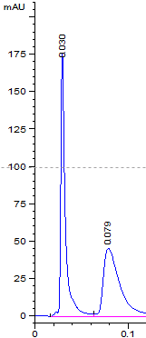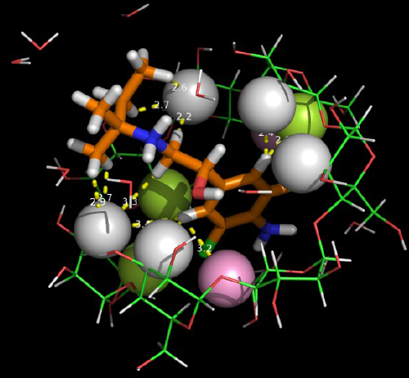

**TSU Building 1**

**Auditorium №115**

**10:00-18:00**

|  |  |
| --- | --- |
| **December 28th, 2017** | |
| **10.00-10.15** | **Symposium Opening** |
| **10.15-11.00** | Our studies on chiral recognition and enantiomer separations in 2017  **Bezhan Chankvetadze,** Tbilisi State University, Tbilisi, Georgia |
| **11.00-11.45** | An overview of carbon based nanosensors in drug assay  **Siebel Ozkan**, Ankara University, Ankara, Turkey |
| **11.45-12.30** | Aminoglycosides: from antibiotics to cellular delivery vehicles, **Alessandro Volonterio,** Politecnico di Milano, Milan, Italy |
| **12.30-13.15** | Importance of small but essential details in proper laboratory practice.  **Vladimir Ioffe,** Teva Pharmaceuticals, Petach Tikwa, Israel |
| **13.15-13.45** | Quantum - chemical description of proton transfer in chemical and biochemical molecular systems  **Djumber Kereselidze,** Tbilisi State University, Tbilisi, Georgia |
| **13.45-14.00** | Determination of the antioxidant activity of red wines Kindzmarauli and Saperavi from Georgia using high-performance liquid chromatography  **Antonina Mskhiladze,** Sukhumi State University, Tbilisi, Georgia |
| **14:00-15:00** | **Lunch and Conference Photo** |
| **15.00-15.30** | Synthesis, structural elucidation and biological activity of benzimidazole derivatives and analogues  **Cigdem Karaaslan,** Ankara University, Ankara, Turkey |
| **15.30-15.50** | Heavy metals in Georgian red wines Kindzmarauli and Saperavi  **Lali Akhalbedashvili**,Tbilisi State University, Institute of Materials Research, Tbilisi, Georgia |
| **15.50-16.10** | Homogeneous inhibition of methane combustion  **George Bezarashvili,**Tbilisi State University, Tbilisi, Georgia |
| **16.10-16.30** | Validation of HPLC methods for the analysis of nanoparticle- based drug delivery systems  **Mehmet Gumustas,** Ankara University, Faculty of Pharmacy, Department of Analytical Chemistry, Ankara, Turkey and Hitit University, Faculty of Arts&Sciences, Department of Chemistry, Çorum, Turkey |
| **16.30-17.00** | SMART|AtmoSim_LAB: first results  **George Jibuti,** Tbilisi State University, Tbilisi, Georgia |
| **December 29th, 2017** | |
| **10.00-10.20** | Comparative enantiomer-resolving ability of coated and covalently immobilized versions of cellulose 3,5-dichlorophenylcarbamate-based chiral selectors in high-performance liquid chromatography  **Eka Tsutsqiridze,** PhD student, Tbilisi State University, Tbilisi, Georgia |
| **10.20-10.40** | Design of a nanosensor for the analysis of anticancer drug  **Leyla Karadurmus,** PhD student, Adıyaman University, Faculty of Pharmacy, Department of Analytical Chemistry, Adıyaman, Turkey and Ankara University, Faculty of Pharmacy, Department of Analytical Chemistry, Ankara, Turkey |
| **10.40-11.00** | Comparative enantiomer-resolving ability of coated and covalently immobilized versions of amylose 3,5-dimethylphenylcarbamate-based chiral selectors in high-performance liquid chromatography  **Nino Beridze,** PhD student, Tbilisi State University, Tbilisi, Georgia |
| **11:00-11:30** | Chiral sulfoxides and characterization of chiral selector-analyte interactions  **Rusudan Kakava,** PhD student, Tbilisi State University, Tbilisi, Georgia |
| **11.30-12.00** | Enantioseparation of chiral sulfoxides in high-performance liquid chromatography with polysaccharide-based chiral selectors and aqueous-organic phases  **Zoia Shedania,** PhD student, Tbilisi State University, Tbilisi, Georgia |
| **12.00-12.30** | Chiral separation in capillary electrophoresis with cyclodextrin-type chiral selectors and investigation of structure of selector- selectand complexes by using nuclear magnetic resonance spectroscopy  **Anna Gogolashvili,** PhD student, Tbilisi State University, Tbilisi, Georgia |
| **12.30 – 12.45** | High-performance liquid chromatographic separation of stereoisomers of chiral basic agrochemicals with polysaccharide-based chiral columns and polar organic mobile phases  **Gizo Dolidze,** BS student, Tbilisi State University, Tbilisi, Georgia |
| **12.45-13.00** | High-performance liquid chromatographic separation of enantiomers of acidic chiral compounds with novel chiral column Chiralpak IG and polar organic mobile phases  **Giorgi Kobidze,** BS student, Tbilisi State University, Tbilisi, Georgia |
| **13.00 -13.15** | Separation method of enantiomers of basic compounds using high-performance liquid chromatography  **Levan Samarguliani,** BS student, Tbilisi State University, Tbilisi, Georgia |
| **13.15 -13.30** | Reversal of enantiomer elution order with varying mobile phases, chiral selectors and temperature in high-performance liquid chromatography  **Ilia Aduashvili,** BS student, Tbilisi State University, Tbilisi, Georgia |
| **13.30 -13.45** | Comparative enantiomer-resolving ability of coated and covalently immobilized versions of amylose 3-chloro-5-methylphenylcarbamate-based chiral selectors in high-performance liquid chromatography with acetonitrile as a mobile phase  **Eka Nadiradze,** BS student, Tbilisi State University, Tbilisi, Georgia |