Dear Colleagues,

we have the great pleasure to invite all those who are interested in Caucasus issues to Rzeszów for the

8th International Scientific Conference
"CAUCASUS – Experiences of the Past – Perspectives of the Future"

which will take place on October 10-11, 2019.

The conference is interdisciplinary and covers the period from antiquity to the modern times. Its aim is to present the latest research results on the Caucasus issues and to create conditions for discussion and exchange of views among international researchers. We also hope that one of the outcomes of the conference will be the integration of the scientific community and the development of cooperation between scientists and research centers in Poland and the Caucasus.

We invite to participate in the conference academics, specialists, researchers, PhD and students who undertake scientific activities on the Caucasus issues in various scientific fields from Poland and other countries, especially from the Caucasus region, as well as representatives of the Polish diaspora from the Caucasus and the Caucasian nations in Poland.

The conference will be conducted in Polish, Russian and English. The result
of the conference will be a scientific publication.

On behalf of the organizers
Dariusz Popek
CAUCASUS–Past–Present–Future

REGISTRATION FORM

Please send filled registration form until September 2, 2019 r.
at the following address: kavkaz@ur.edu.pl

Name and surname:……………………………………………...………….…………........
Academic title/ academic degree/ academic position:………………………………...
Institutional affiliation:….……………………………………………….………..…..........
Contact phone number: ………………… e-mail address: …………………………

Title of the proposed paper:

…………………………………..………………………......................................................

ABSTRACT (max 200 words)
…………………………………………………………………………..………………………
…………………………………………………………………………..………………………

Technical requirements for presentation:.................................................................

Meals (please indicate dietary requests, if you have any):

[ ] vegetarian meals/ vegan meals ………………………………………………………….
[ ] food allergies (please indicate allergens) ..……………………………………………...
[ ] religious dietary requirements (please describe) ………………………………………
[ ] others (please describe) ………………………………………………......……………...

Accommodation (please indicate proper option):
[ ] 09/10.10.2019 r. [ ] 10/11.10.2019 r. [ ] 11/12.10.2019 r. [ ] no need

If you need invoice, please provide invoice data:
Name (first name and surname/ or university, academy, school/ or institution): ……….
…………………………………………………………….…………………………………….
Address: ………………………………………………………………………………………..
Invoice delivery address: ……………………………………………………………………..
Additional info: …………………………………………………………………………………

CONFERENCE FEE

Please indicate one of the options:

[ ] 50 euro
(participation in the conference and publication of the submitted paper).
[ ] 70 euro
(Participation in the conference, meals during the conference, including official gala supper for all the conference participants, and publication of the conference paper).
[ ] 95 euro
(Participation in the conference, one night's accommodation, meals during the conference, including official gala supper for all the conference participants, and publication of the conference paper).
[ ] 120 euro
(Participation in the conference, two night's accommodation, meals during the conference, including official gala supper for all the conference participants, and publication of the conference paper).
[ ] 145 euro
(Participation in the conference, three night's accommodation, meals during the conference, including official gala supper for all the conference participants, and publication of the conference paper).

Submitted articles will be published in the monograph series of the Institute of History at University of Rzeszów "Between East and West. Caucasus Yesterday and Today" or in the scientific journal "CAUCASUS-Past-Present-Future". The organizers reserve the right to choose the place of publication of the submitted papers.

Deadline for paying conference fee: September 2, 2019 r.

Bank transfer details:
Account owner: University of Rzeszów. Address: Al. Rejtana 16 c, 35-959 Rzeszów.
Bank Account: 50 1030 1999 7896 0000 0190 0084
Transfer title: Kaukaz 2019
SWIFT Bank Handlowy: CITIPLPX

In any organizational matters please contact the conference secretariat at: kavkaz@ur.edu.pl.

Conference venue: University of Rzeszów, prof. Stanislaw Pigon Street 1, 35-959 Rzeszów, building no. A0, assembly hall A0.

SCIENTIFIC COMMITTEE

- Sylwester CZOPEK Prof.
Rector of the University of Rzeszów
- Marek KOZIOROWSKI Prof.
Vice-Rector for Science and International Cooperation at the University
of Rzeszów
- Wojciech WALAT Prof.
Vice-Rector for Student Affairs and Education at the University of Rzeszów
- Paweł GRATA Prof.
Dean of the Faculty of Sociology and History at the University of Rzeszów
- Krzysztof PIETKIEWICZ Prof.
Head of Institute for Eastern Studies at the Adam Mickiewicz University
in Poznań
- Andrzej BONUSIAK Prof.
Head of Institute of History at the University of Rzeszów
- Nikolai SUDAVCOV prof.
North-Caucasus Federal University
- Waldemar REZMER Prof.
University of Nicolaus Copernicus in Torun
- Antoni MIRONOWICZ Prof.
University of Bialystok
- Azad RZAJEV Prof.
Baku State University

- Maria FILINA Prof.
Cultural and Educational Association of Poles in Georgia "Polonia"
Ketevan KHUTSISHVILI Prof.
- Ivane Javakhishvili Tbilisi State University
- Zalina KANUKOVA Prof.
- Vladikavkaz Scientific Center of the Russian Academy of Sciences
- Dagmara MASLOVA Prof..
Pyatigorsk State University
- Svetlana AKKIEVA Prof.
Kabardino-Bałkarski Institute of Humanities
- Ruslan SEFERBEKOV Prof.
Dagestan State University
- Seifulla RASHYDOV Prof.
Izmail State University of the Humanities
- Alexander MARKAROV Prof.
Yerevan State University
- Vadim ZADUNAJSKI Prof.
Ukrainian Catholic University
- Ibragim IDYLOV Prof.
Grozny State Oil Technical University named after academician
M. D. Millionshtchikov
- Roustam BEGEULOW Prof.
Karachay-Cherkess State University named after U. D. Aliyev
- Evgeny KRINKO PhD.
Southern Science Center of the Russian Academy of Sciences

ORGANISING COMMITTEE

- Dariusz POPEK
CAUCASUS – Past – Present – Future
- Paweł KORZENIOWSKI
University of Rzeszów
- Hubert KOTARSKI
University of Rzeszów
- Bogdan WIERZBIŃSKI
University of Rzeszów
- Tomasz WARZOCHA
University of Rzeszów
- Dariusz KRÓL
University of Rzeszów
- Damian KNUTEL
University of Rzeszów
- Grzegorz SKRUKWA
Adam Mickiewicz University in Poznań
- Magda PABIN – MAJCHRZYK
Adam Mickiewicz University in Poznań
- Julia KACZMAREK – KHUBNAIA
Adam Mickiewicz University in Poznań
- Dagmara MOSKWA
Polish Academy of Sciences
- Stanisława BUDZISZ – CYSEWSKA
University of Gdańsk
- Anna PAJĄK
Jagiellonian University
- Mateusz ISKRA
University of Warsaw
- Ewa WOLSKA – LIŚKIEWICZ
CAUCASUS – Past – Present – Future
- Klaudia ORDZOWIAŁY–GRZEGORCZYK
CAUCASUS – Past – Present – Future
- Weronika JAWORSKA
CAUCASUS – Students and PhD Scientific Circle of the University of Rzeszów
- Paweł PARYNA
CAUCASUS – Students and PhD Scientific Circle of the University of Rzeszów

INFORMATION CLAUSE

8th International Scientific Conference
"Caucasus - Experience of the Past - Perspectives of the Future"
Rzeszów, October 10-11, 2019.

According to art. 13 of the general regulation on the protection of personal data - RODO of 27 April 2016 (Journal of Laws UE L 119 of 04.05.2016) University of Rzeszów informs that:

- The administrator of Personal Data is the University of Rzeszów, Aleja Rejtana 16c,
35-959 Rzeszów, tel. + 48 17 872 10 00 (telephone exchange), tel / fax:
48 17 872 12 65, e-mail: info@ur.edu.pl, NIP: 813-32-38-822, REGON: 691560040
- Krystian Antochów is the Inspector of Data Protection at the University of Rzeszów. Current contact details to the Inspector of Data Protection are available at +48 17 872 34 39, +48 17 872 36 46 and e-mail address: iod@ur.edu.pl.
- Your personal data will be processed in order to register, organize and conduct the conference, pursuant to Article 6 para. 1 lett. a, general regulation on the protection of personal data of 27 April 2016. The basis for the processing of your personal data is the consent to the processing of personal data. Providing data is voluntary, but necessary to achieve the goals for which they were collected.
- The data will not be made available to external entities, except for cases provided for by law and cooperating entities with the data administrator in the scope of the conference.
- The data will be stored for the period necessary to achieve the above-mentioned objectives, and after that for the period and to the extent required by the generally applicable law.
- You have the right to access your data and, subject to the law, the right to rectify, delete, limit processing, the right to transfer data, the right to object to the processing. If the processing of personal data is based on your consent, you have the right to withdraw your consent at any time. Withdrawal of consent has consequences for the future. Withdrawal of consent does not affect the lawfulness of the processing that was made on the basis of consent before its withdrawal.
- You have the right to lodge a complaint with the supervisory body.
- The data provided by you will not be processed in an automated manner and will not be subject to profiling.
- The administrator has no intention of transferring personal data to a third country or an international organization.

Consent for the processing of personal data:

I agree to the processing of my personal data for the purposes of registration, organization and conduct of the 8th International Scientific Conference "Caucasus
- Experience of the Past - Perspectives of the Future", Rzeszów, October 10-11, 2019. I have knowledge that providing data is voluntary, but necessary to implement the purpose for which they were collected.

Date and signature

I acknowledge that the Administrator of personal data is the University of Rzeszów and I declare that the information obligation has been fulfilled for me.

Date and signature

Statement:

I declare that I have read and accept all the conference terms contained in the conference announcement documentation.

Date and signature

Permission to use my personal portrayal/ image:

I agree to the free use and distribution of my personal portrayal/ image (including any photographs and film documentation made during the conference) by the University of Rzeszów. This consent is free, unlimited in quantity, temporarily or territorially. This consent covers all forms of publication, in particular dissemination on the Internet and inclusion in promotional and information materials related with a conference.

Date and signature

ONORARY PATRONAGE

Marshal of the Podkarpackie Voivodeship
Mayor of Rzeszów
Rzeszów Branch of the Association „Wspólnota Polska”

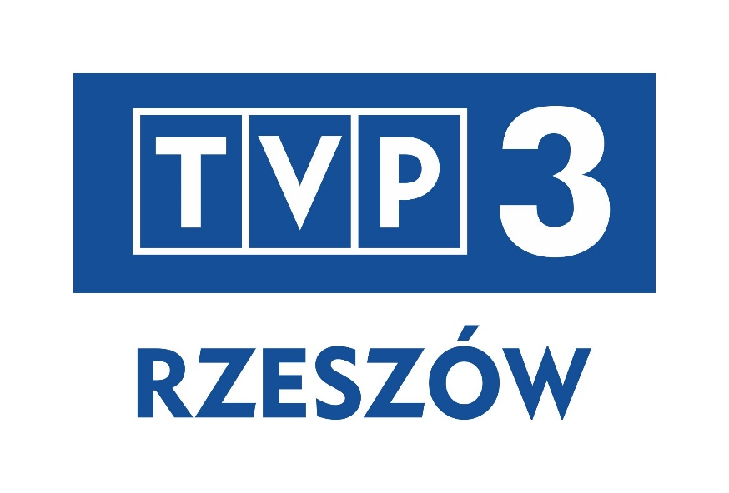
MEDIA PATRONAGE

