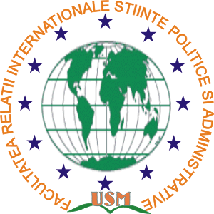


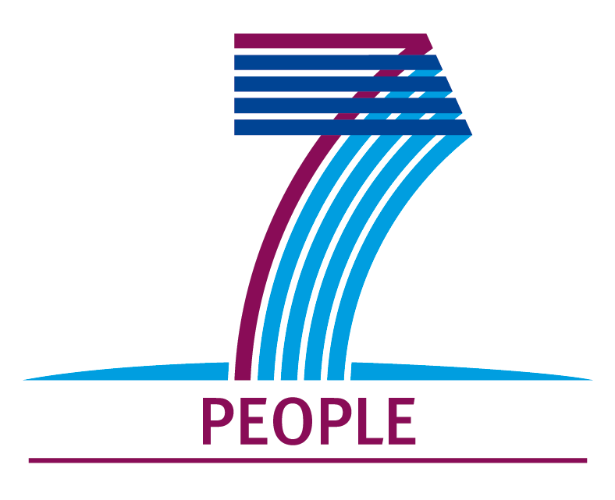

International Scientific Conference
"Political Science and the Changing Society"
REGISTRATION FORM
(Chisinau, November 13th 2015)
Name / Surname: (Mr. / Ms.)______________________________________________________________
Workshop Title:________________________________________________________________________
Place of work (full name of the institution / organization):_______________________________________
_____________________________________________________________________________________
Function, scientific degree and title: ________________________________________________________
Address:______________________________________________________________________________
Phone:____________________________Fax:________________________________________________
E-mail: _____________________________ web site__________________________________________
Form of participation (with or without personal presence): ______________________________________
Please indicate the arrival and departure days for the hotel booking * _____________________________
_____________________________________________________________________________________
* If you need, the organizers could provide assistance for hotel booking. Travel and accommodation expenses will be covered by the participants.

Participation fee is covered by organizers.
Please complete all the information precisely in this form in order to facilitate the preparation of the participants’ list for the conference.
Please send the completed registration form to the workshop address or by e-mail: frispausm@gmail.com until September 4th 2015.

